**10. Kubernetes ReplicaSet – Introduction**

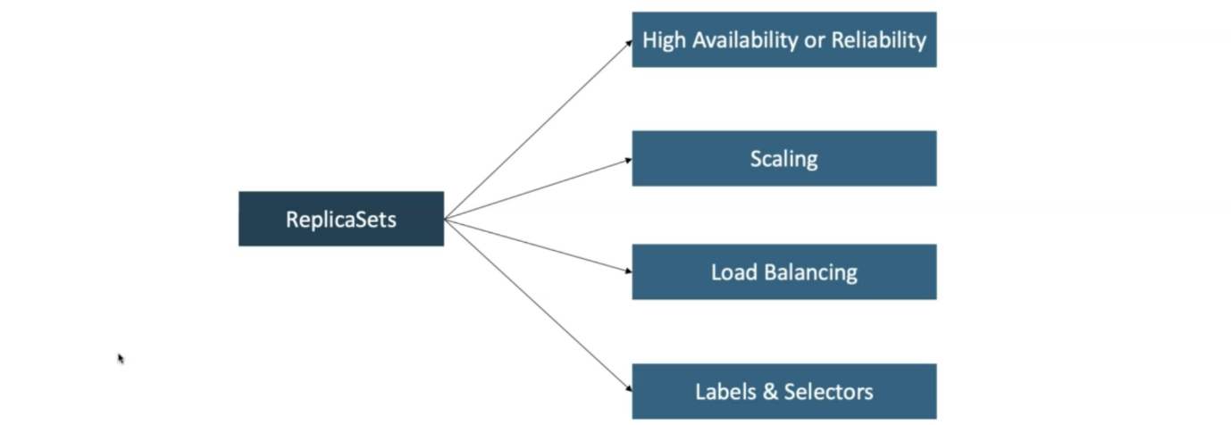

--- **note** – Replicaset helps us achieve the high availability or reliability of our application hosted on kubernetes.

--- it helps us to scale our application. Using labels and selectors we were able to tie all the replicaset, pods and services.

**How Reliability or high availability achieved**

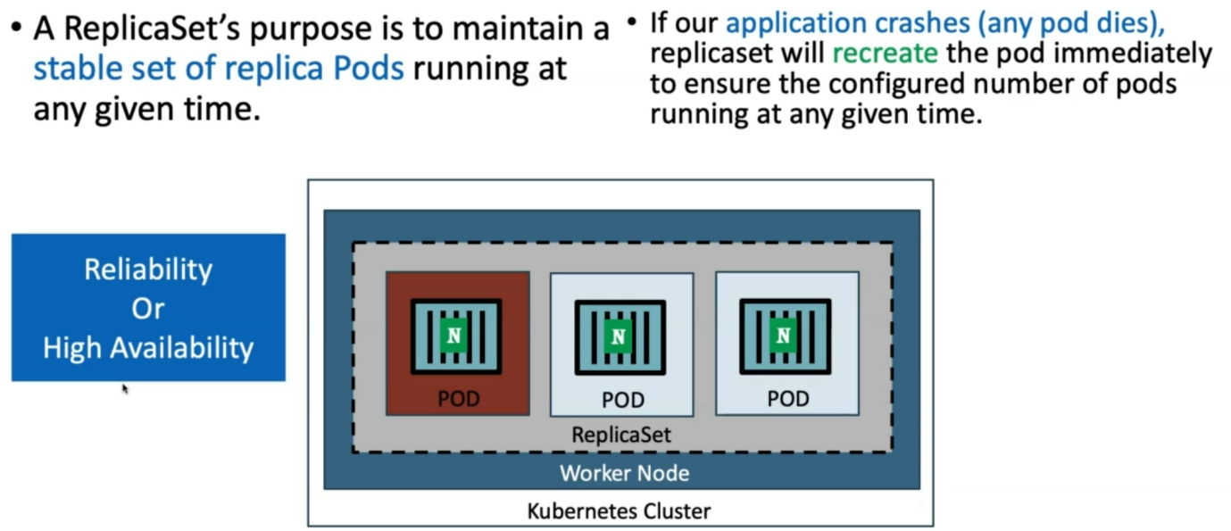

--- **note** – in this way reliability or high availability is achieved.

**Load balancing**

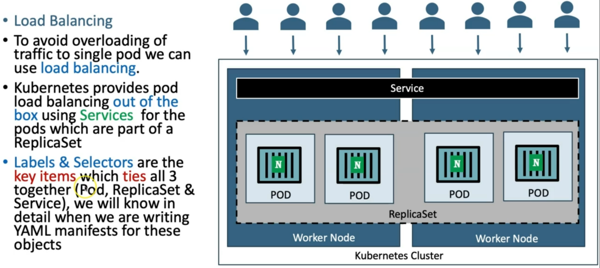

--- **note**- service will act as load balancer and distribute the traffic between different pods. The above four pods are spread over the 2 different worker nodes and the service is acting as a load balancer and distributing the traffic between the pods.

**Scaling**



